# Testing

System testing is a process of testing of full software. System testing makes sure that the system’s functions are working properly or not. It also helps to prevent future risks. It is done before the project is published. It can show us the error we can get while using the system and helps to deal with it.

For this system I have used Black Box testing due to the following reason.

* This test is done by using the point of views of users.
* This test can be immediate done after the system is completed.
* It shows the accurate result because we run the system to do this test.

Black Box testing 1: Registration and its validation

|  |  |  |  |  |  |
| --- | --- | --- | --- | --- | --- |
| Test Case | Description | Task | Expected Result | Actual Result | Conclusion |
| 1 | Register in the system. | Fill all the attributes present. | New account created for the user. | User account created successfully. | Pass |
| 2 | Validation of form. | Leave any attribute blank or incorrect email address format | Show error message to the user. | Error message was displayed to user. | Fail |

Output:

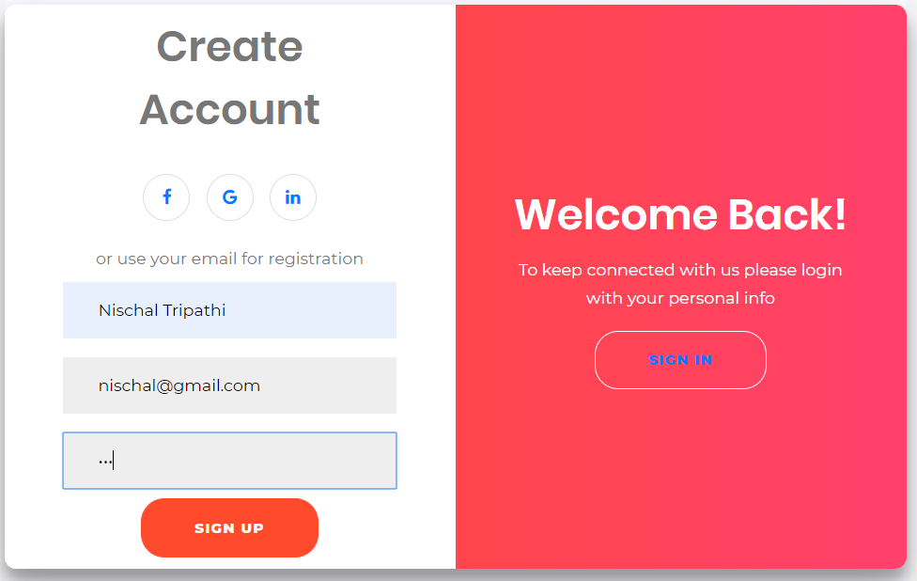

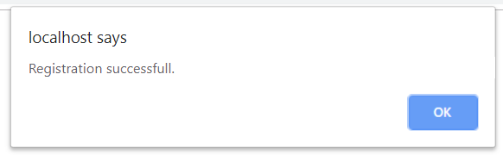

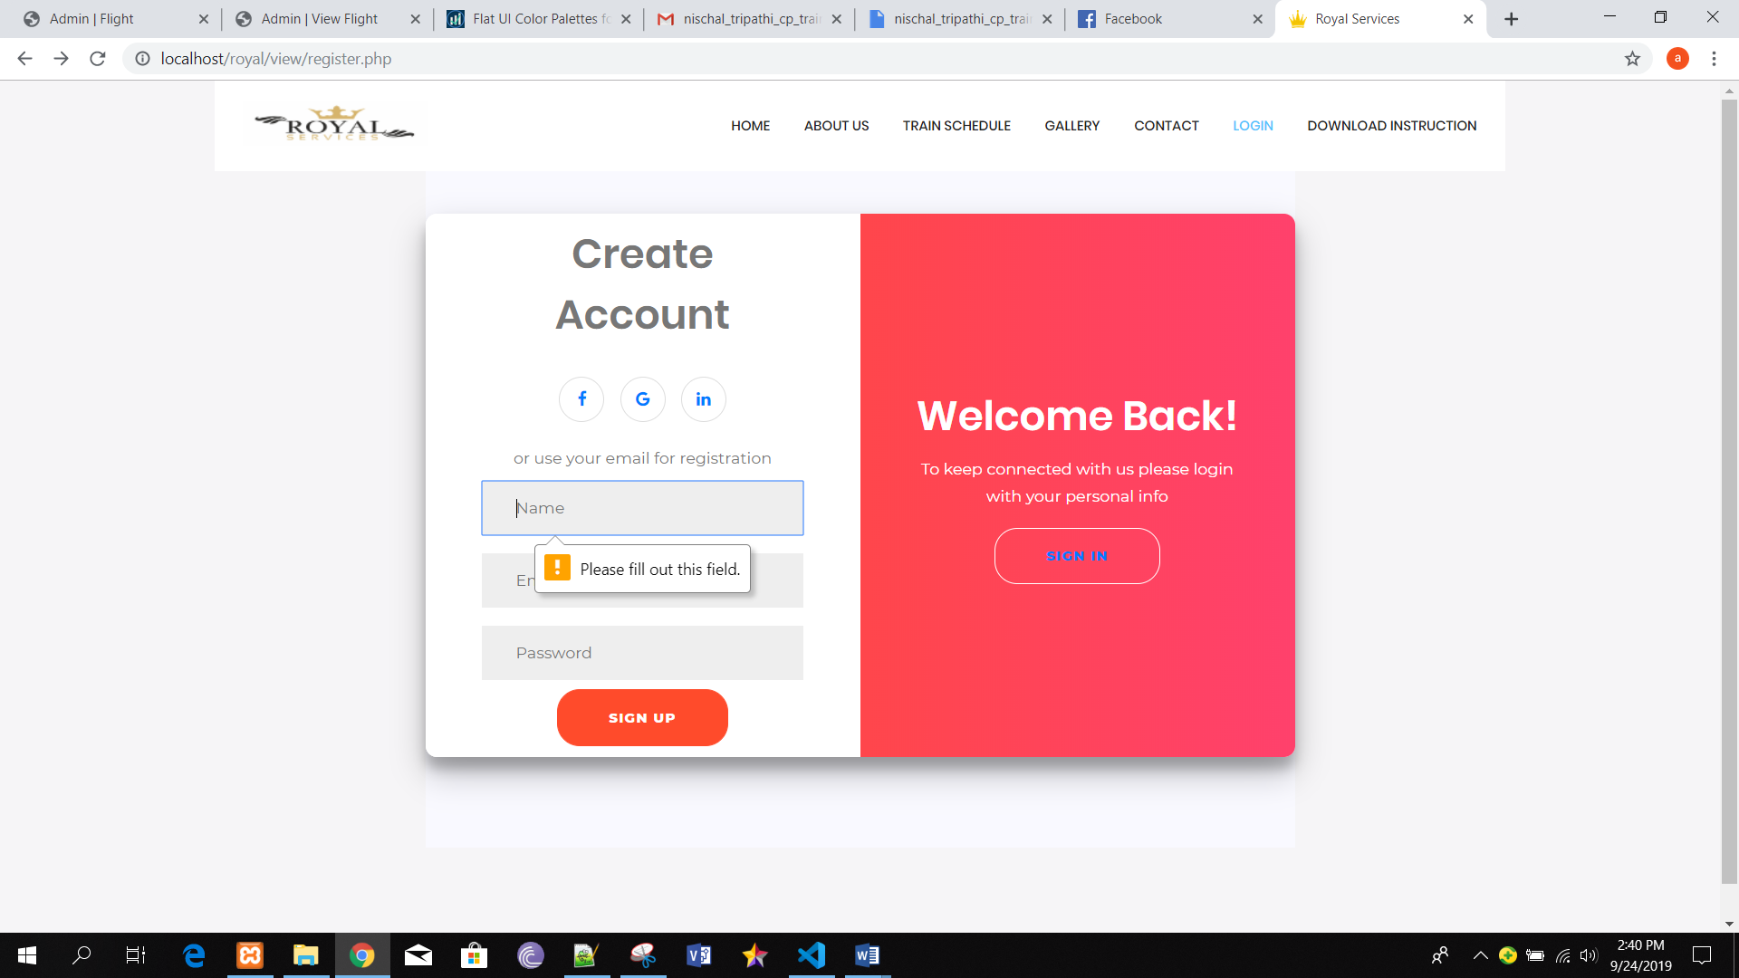

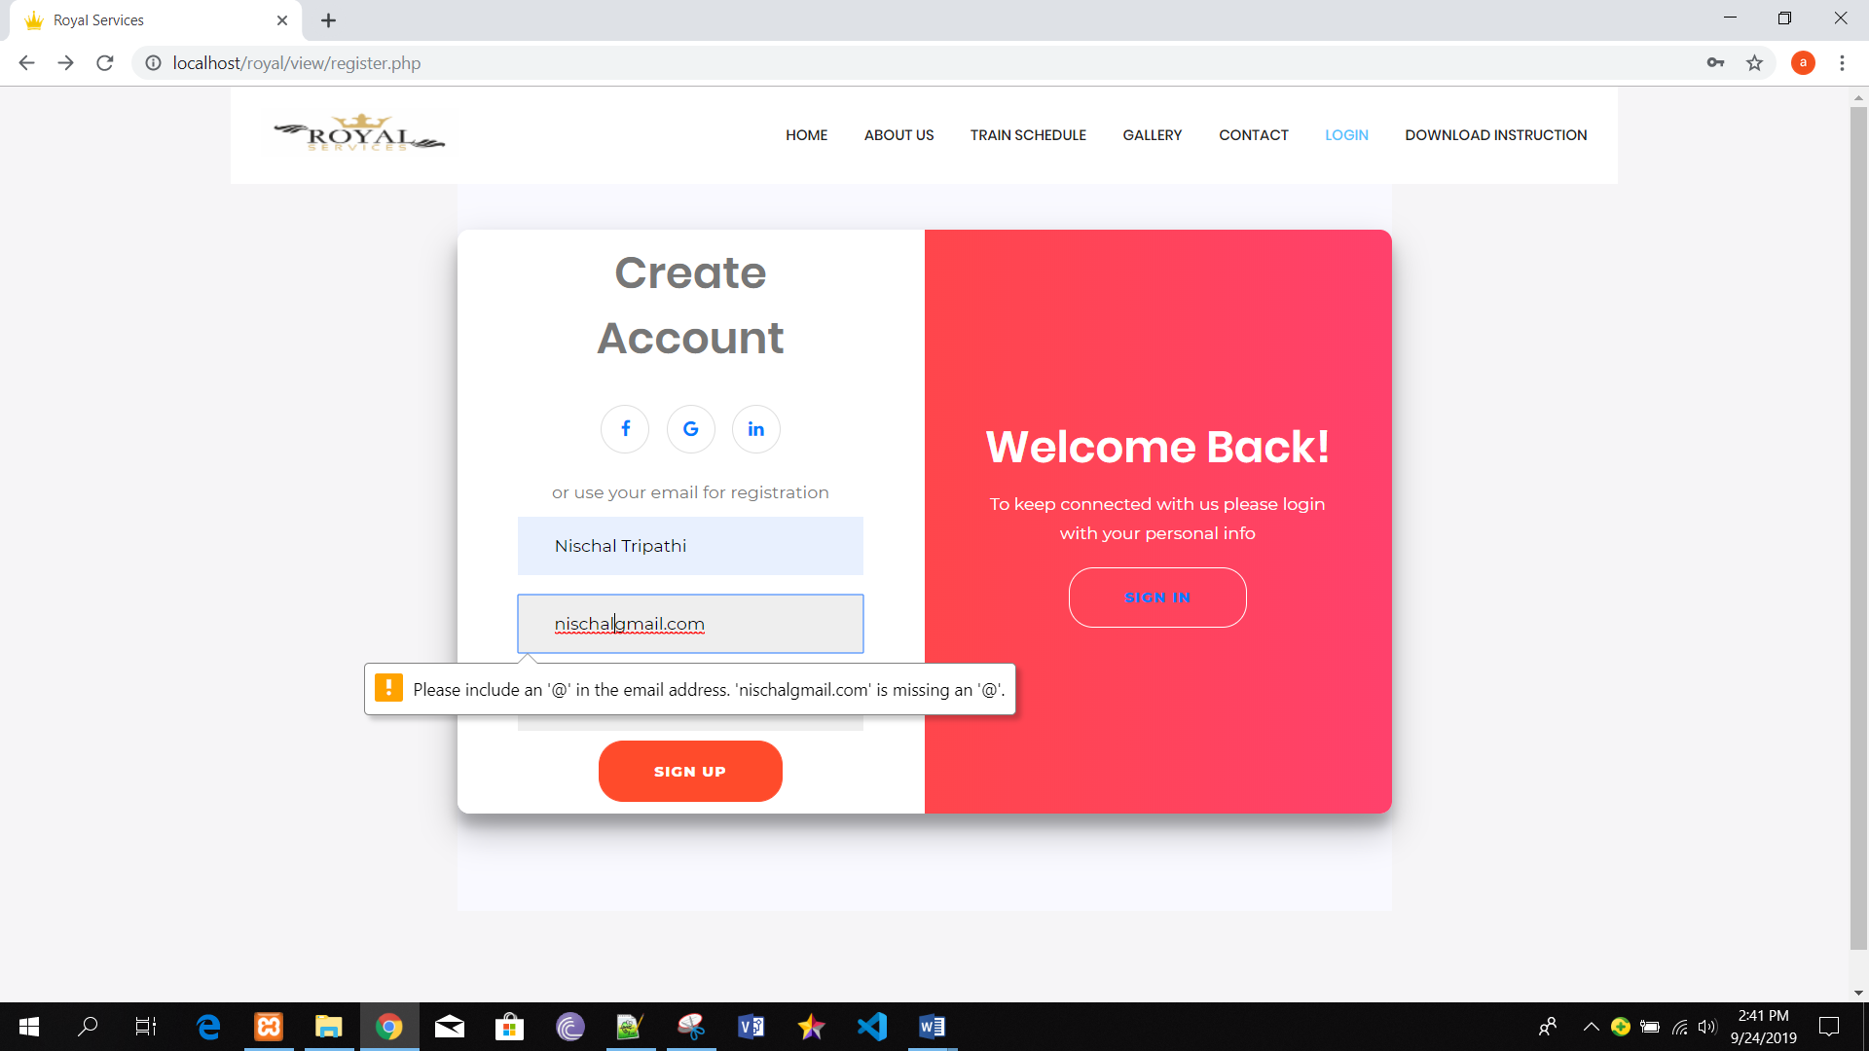

Black box test 2: Login

|  |  |  |  |  |  |
| --- | --- | --- | --- | --- | --- |
| Test Case | Description | Task | Expected Result | Actual Result | Conclusion |
| 1 | Login in the system. | Add email and password. | Login successful. | User logged in successfully. | Pass |
| 2 | Validation of form | Leave all the attribute blank. | Error message must be displayed to the user. | Error message displayed. | Fail |
| 3 | Invalid Login | Add invalid account details. | User blocked for 60 sec after 3rd attempt. | User blocked for 60 sec after 3rd attempt. | Fail |

Output:

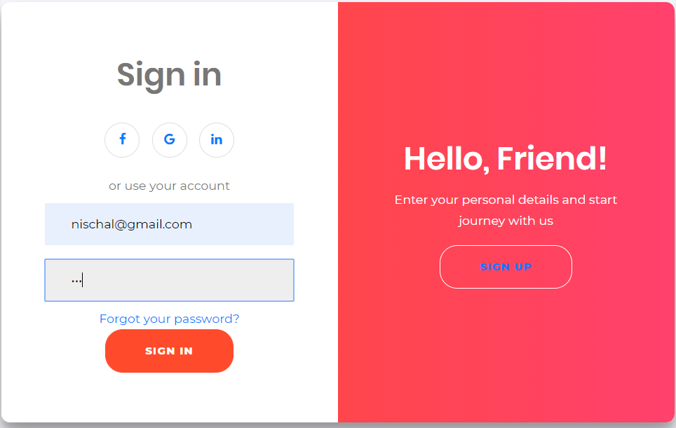

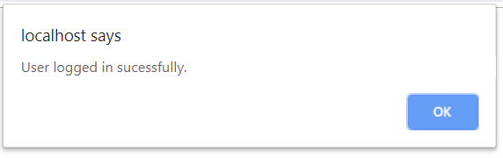

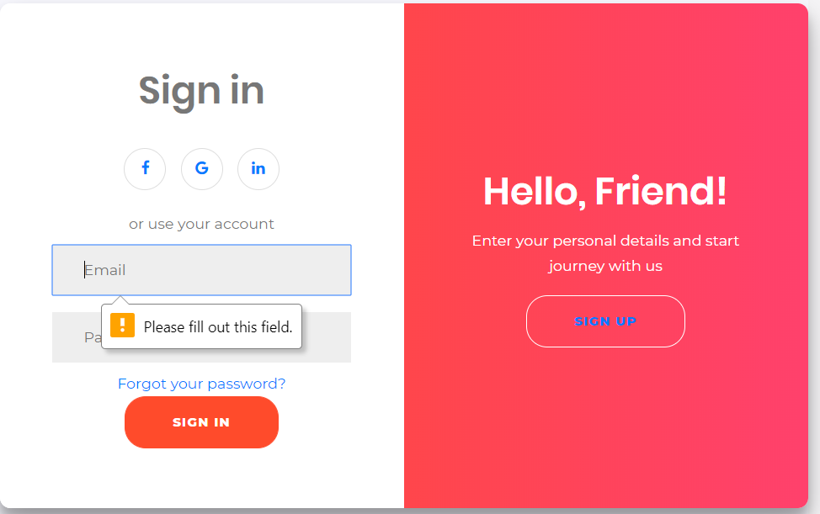

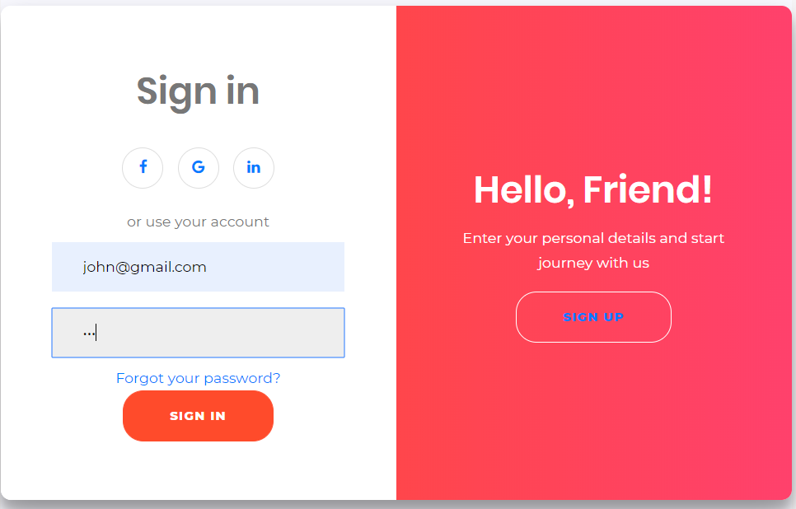

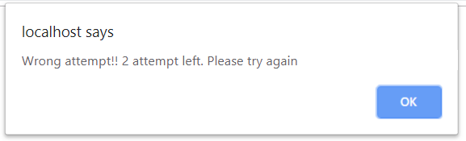

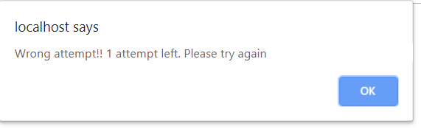

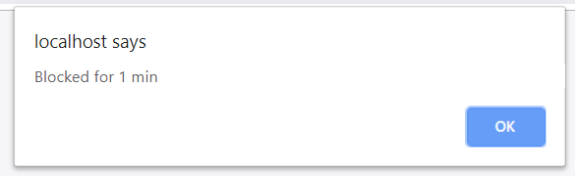

Black box testing 3: Add passenger details

|  |  |  |  |  |  |
| --- | --- | --- | --- | --- | --- |
| Test Case | Description | Task | Expected Result | Actual Result | Conclusion |
| 1 | Add passenger details. | Fill all the given attributes. | Data added successfully. | Data added successfully. | Pass |
| 2 | Form validation | Insert wrong email format. | Error message must be displayed. | Error message displayed. | Fail |

Output:

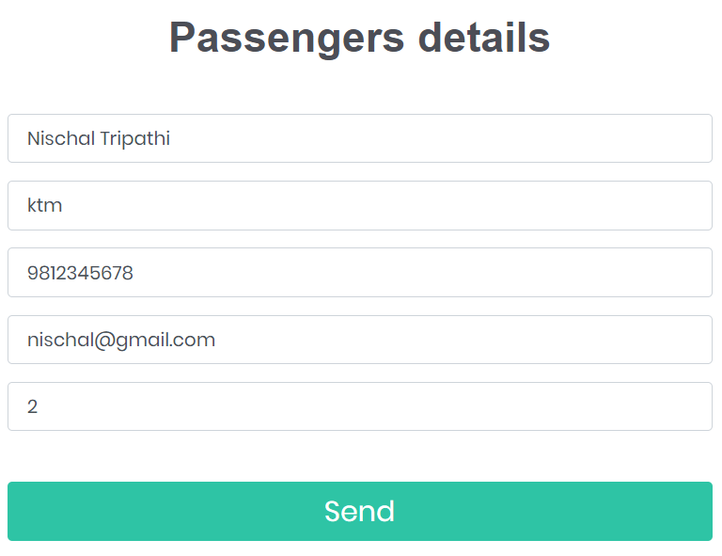

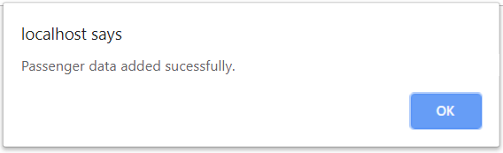

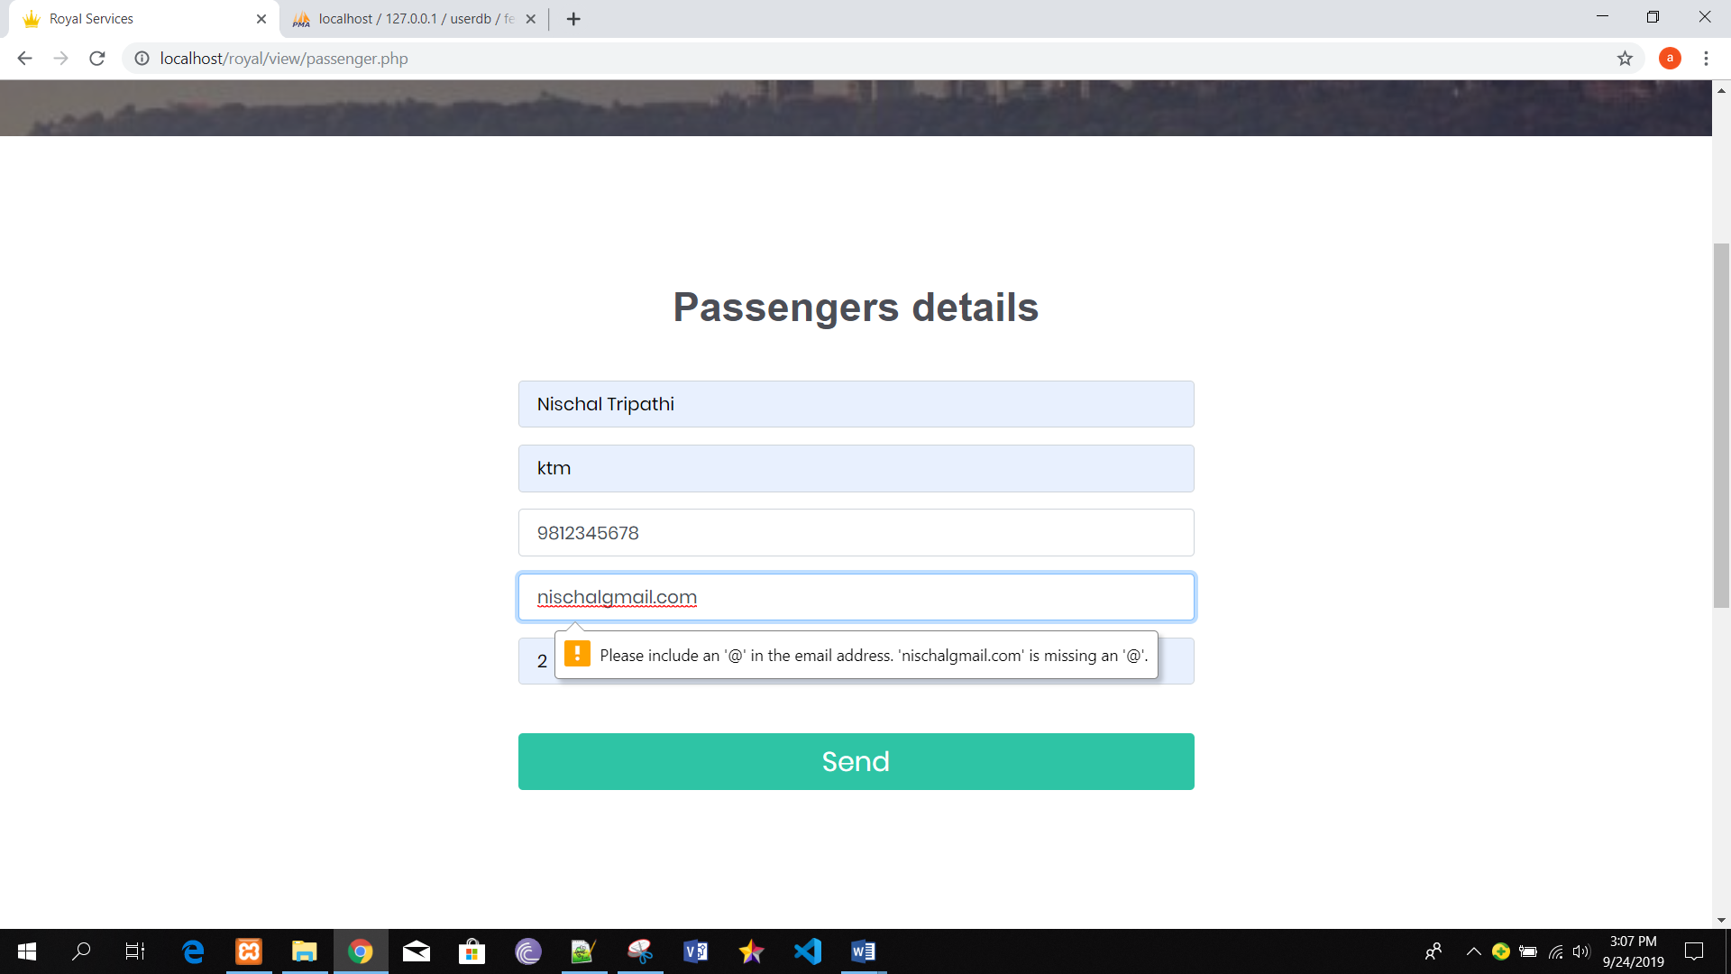

Black box testing 4: Add payment details

|  |  |  |  |  |  |
| --- | --- | --- | --- | --- | --- |
| Test Case | Description | Task | Expected Result | Actual Result | Conclusion |
| 1 | Add payment details. | Fill all the given attributes. | Payment made successfully. | Payment made successfully. | Pass |
| 2 | Form validation | Leave any attribute blank. | Give error message to user. | Error message displayed. | Fail |

Output:

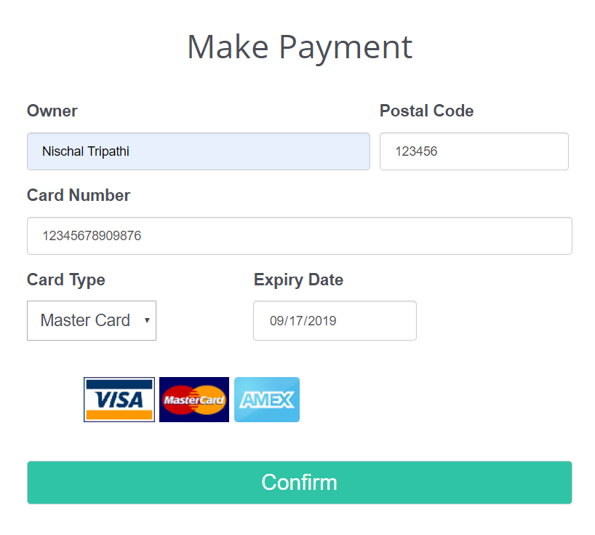

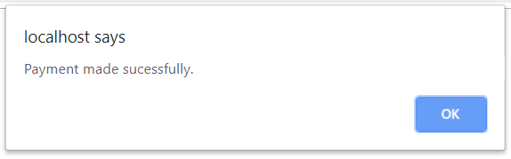

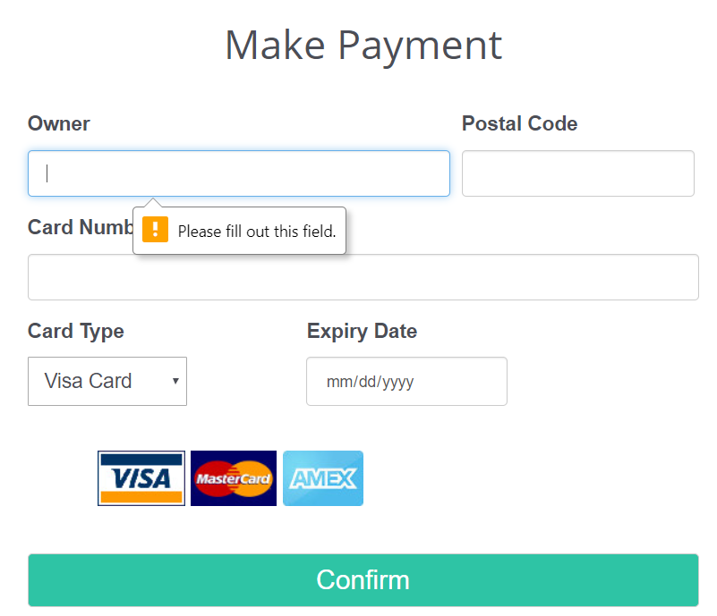

Black box testing 5: Admin Login and validation

|  |  |  |  |  |  |
| --- | --- | --- | --- | --- | --- |
| Test Case | Description | Task | Expected Result | Actual Result | Conclusion |
| 1 | Login in the system. | Add username and password. | Login successful. | User is logged in to the system successfully. | Pass |
| 2 | Invalid Login | Add invalid account details. | Username and password did not match. | Login unsuccessful. | Fail |

Output:

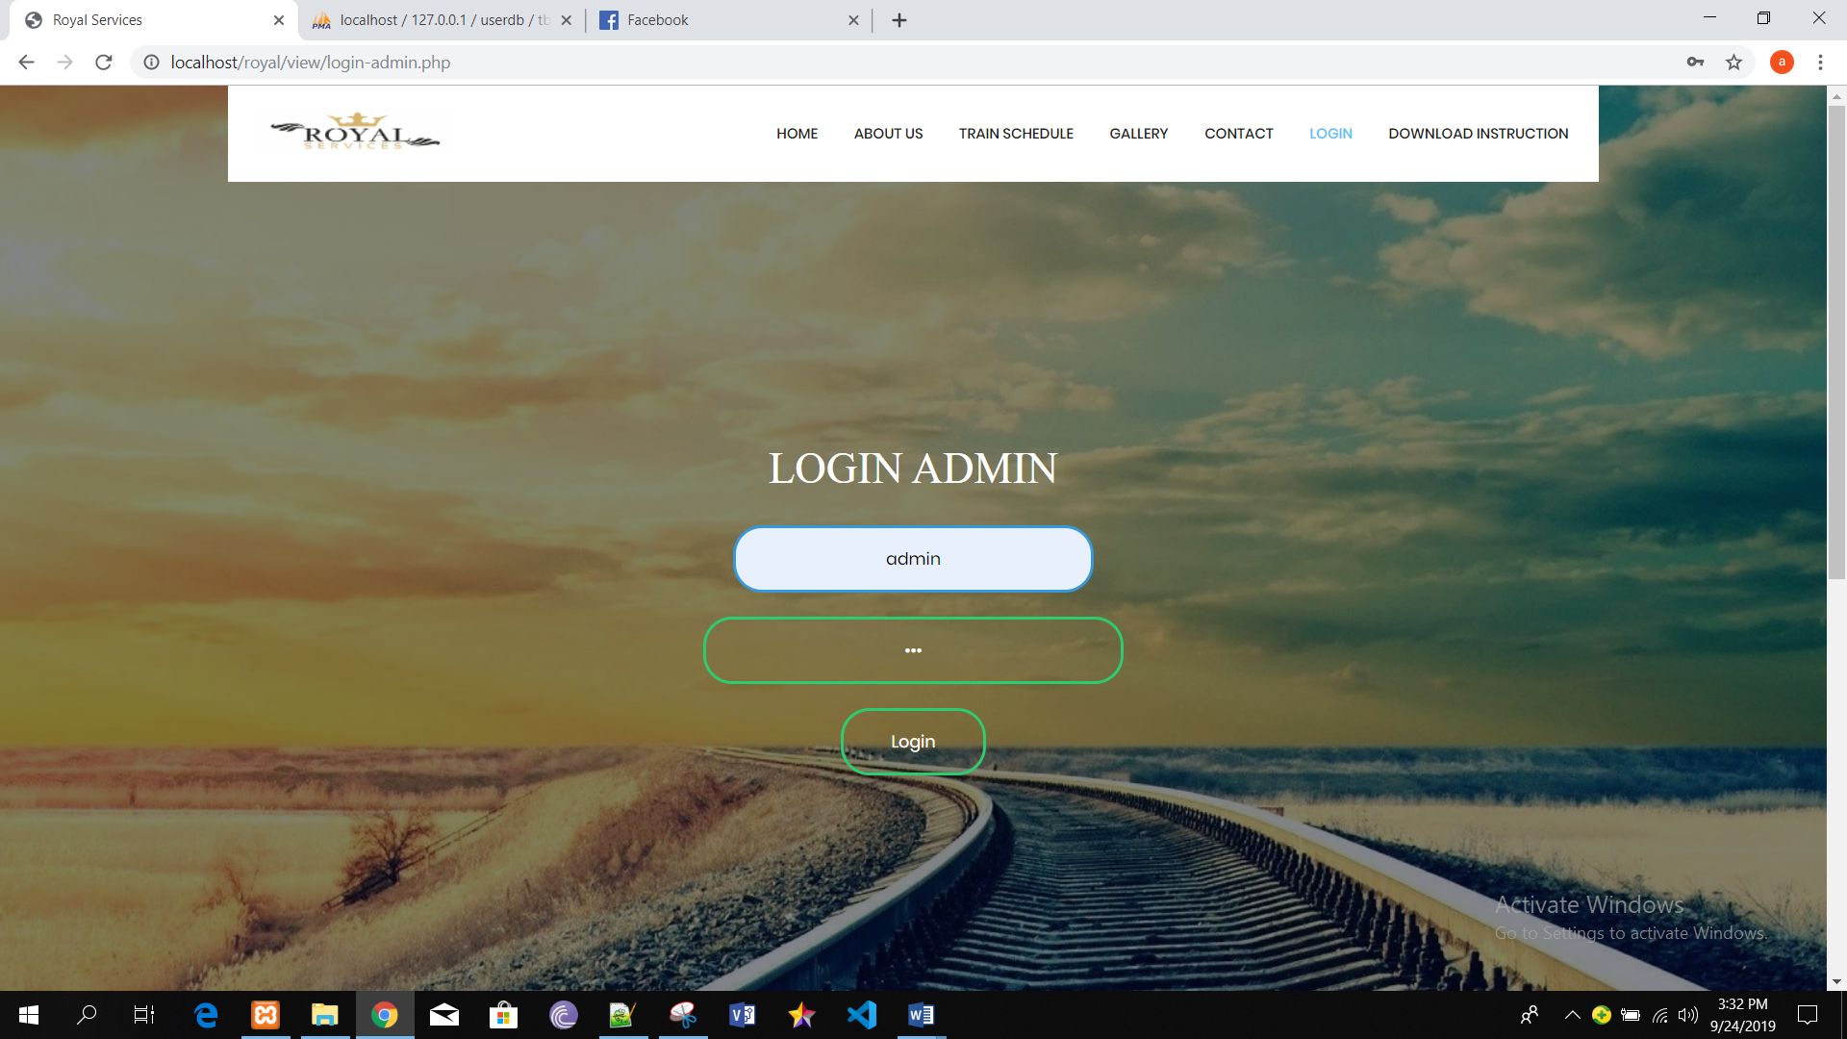

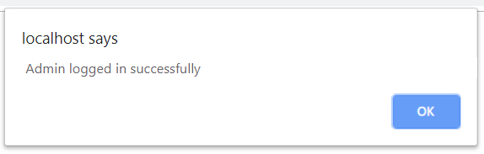

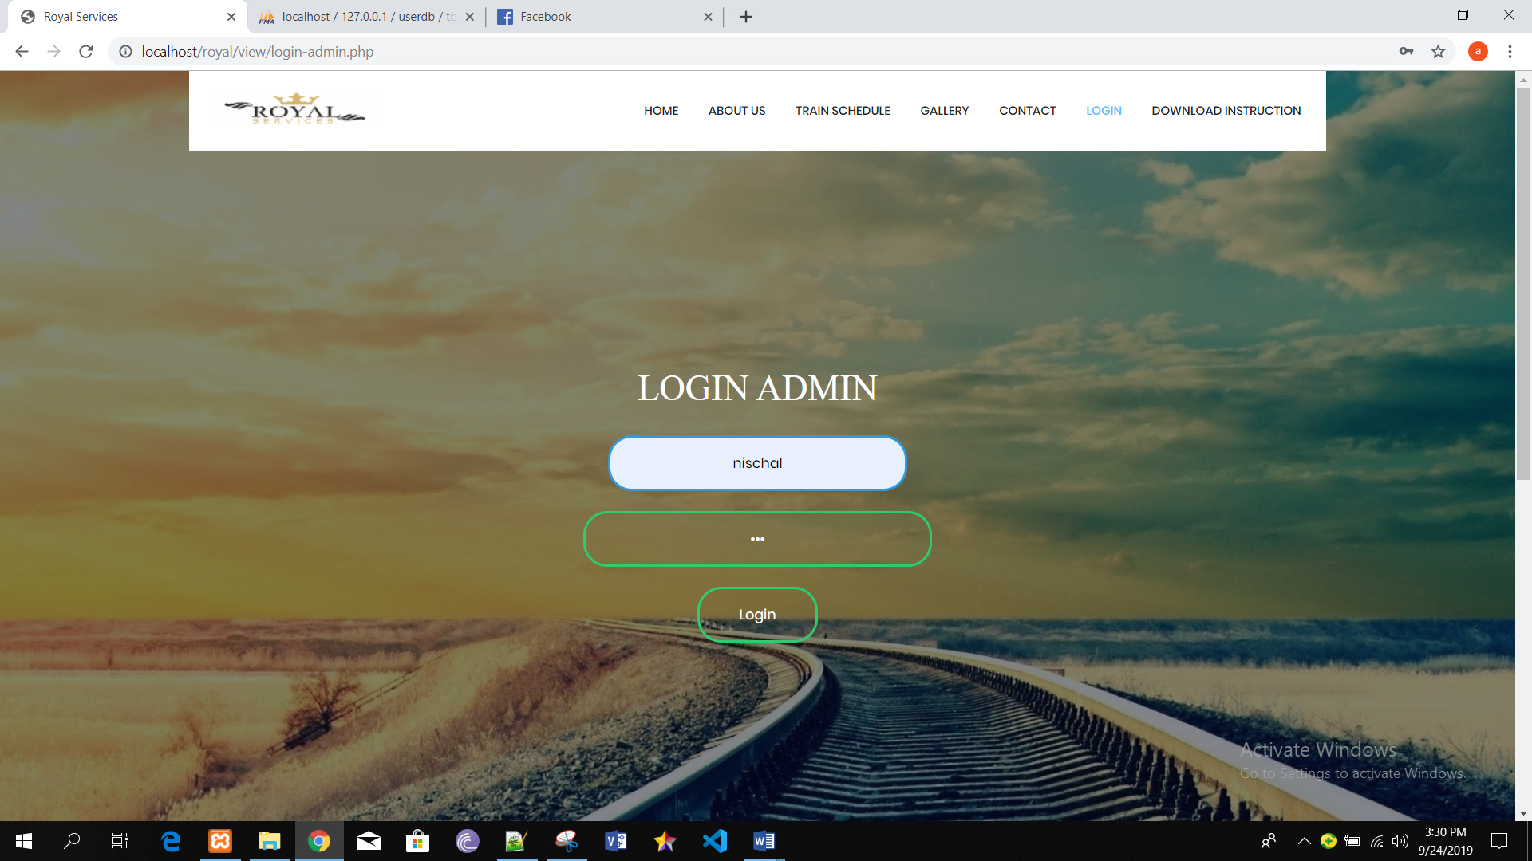

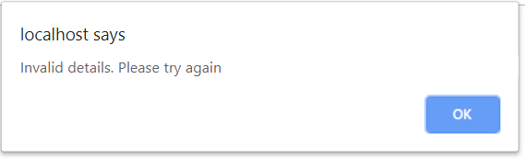

Black box testing 6: Add train details

|  |  |  |  |  |  |
| --- | --- | --- | --- | --- | --- |
| Test Case | Description | Task | Expected Result | Actual Result | Conclusion |
| 1 | Add train details | Fill all the attributes given. | Data must be added successfully. | Train details recorded successfully. | Pass |
| 2 | Validation of form | Leave all attributes blank. | Admin will get an error message of validation. | Admin get an error message. | Fail |

Output:

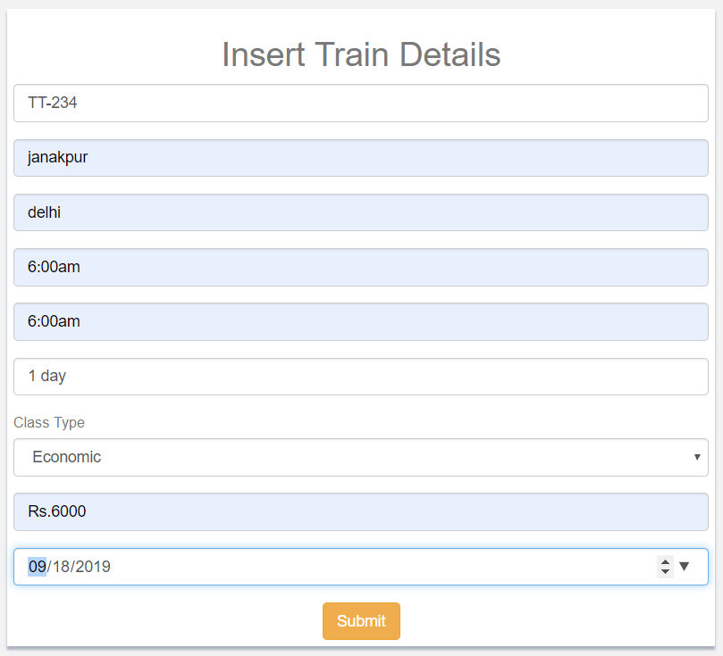

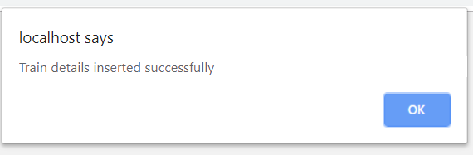

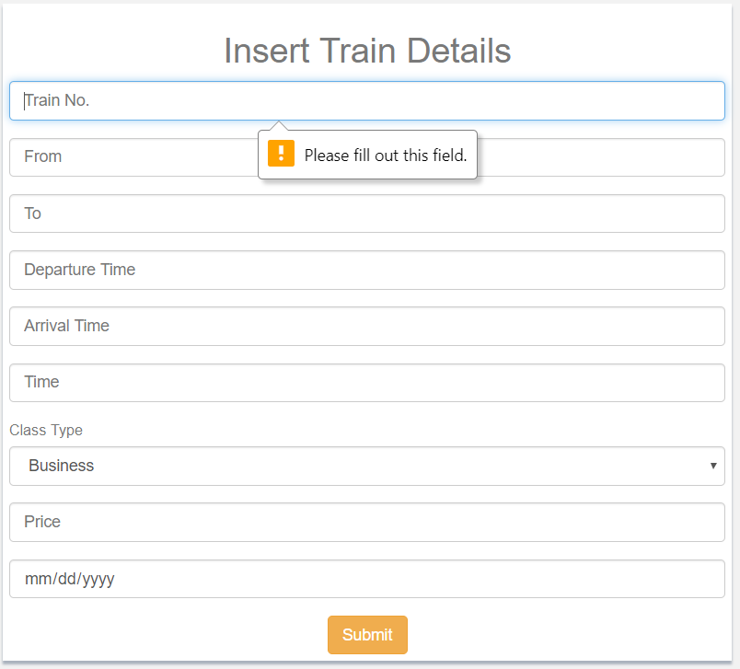

Black box testing 7: Update Train details

|  |  |  |  |  |  |
| --- | --- | --- | --- | --- | --- |
| Test Case | Description | Task | Expected Result | Actual Result | Conclusion |
| 1 | Update train details | Train data must be fetch from train details form. | Train details must be updated successfully. | Record Updated successfully. | Pass |

Output:

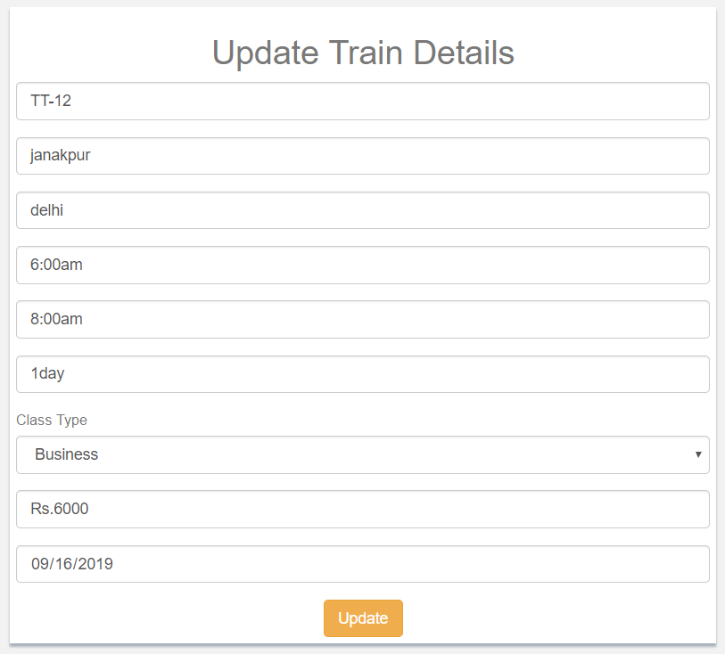

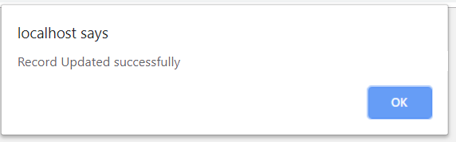

Black box testing 8: Delete train record

|  |  |  |  |  |  |
| --- | --- | --- | --- | --- | --- |
| Test Case | Description | Task | Expected Result | Actual Result | Conclusion |
| 1 | Delete train details | Admin can select the data from table and delete it. | Train record must be deleted from the table. | Record deleted successfully. | Pass |

Output:

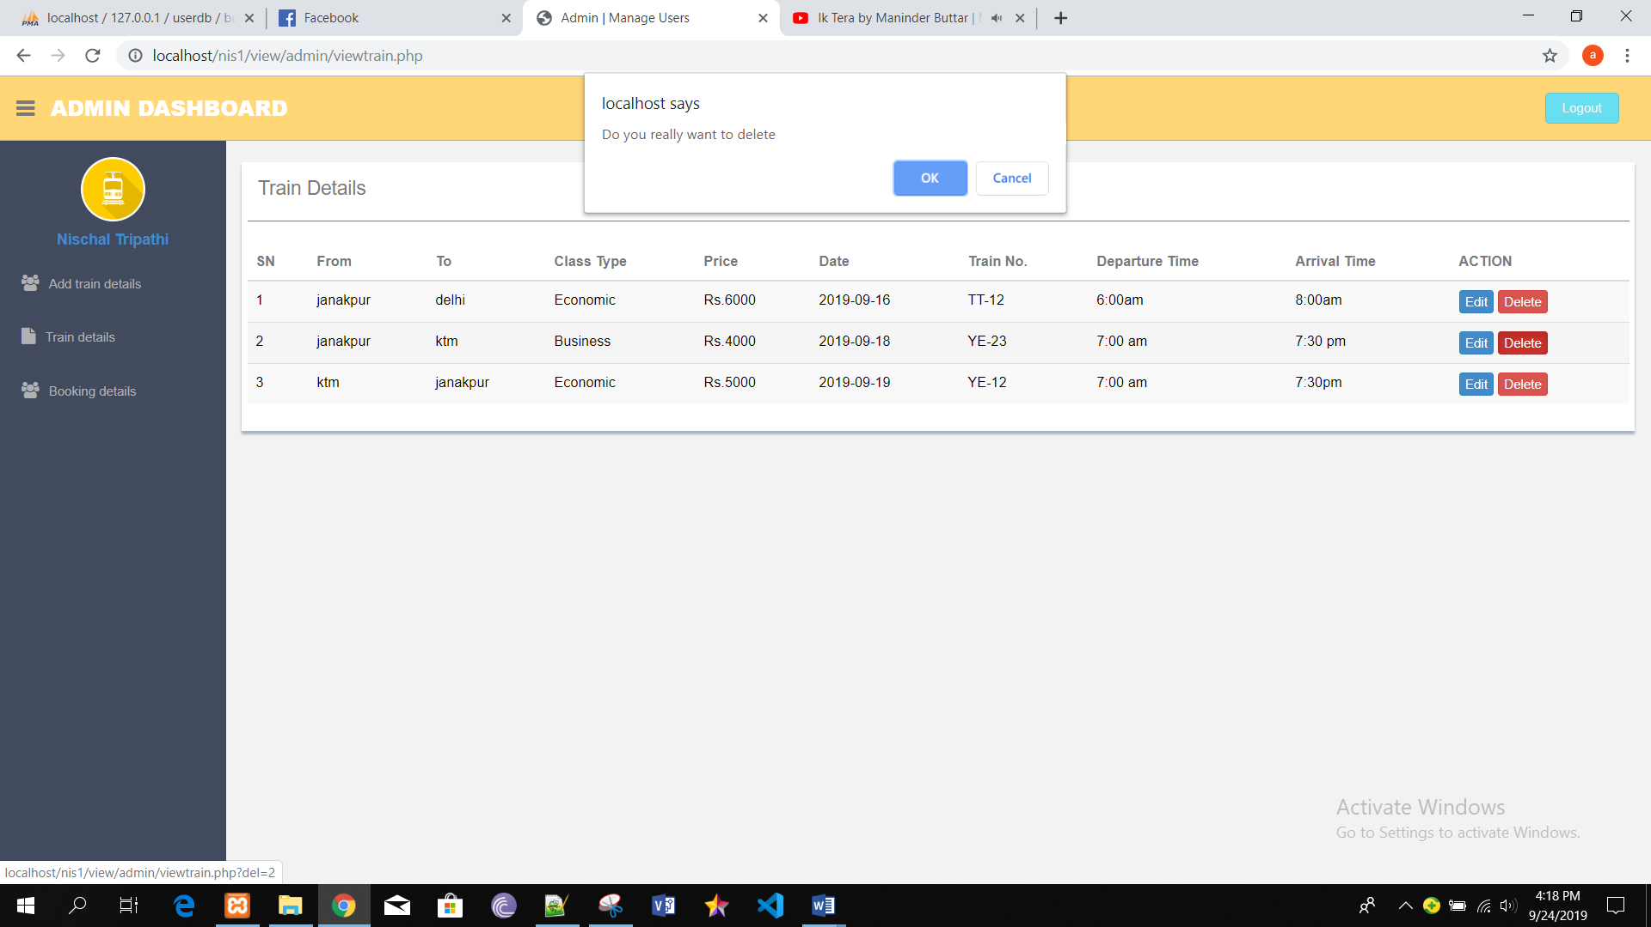

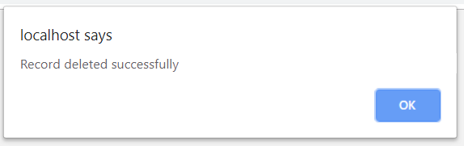

Black box testing 9: Delete Booking record

|  |  |  |  |  |  |
| --- | --- | --- | --- | --- | --- |
| Test Case | Description | Task | Expected Result | Actual Result | Conclusion |
| 1 | Delete booking details | Admin can select the data from table and delete it. | Booking details must be deleted from the table. | Record deleted successfully. | Pass |

Output:

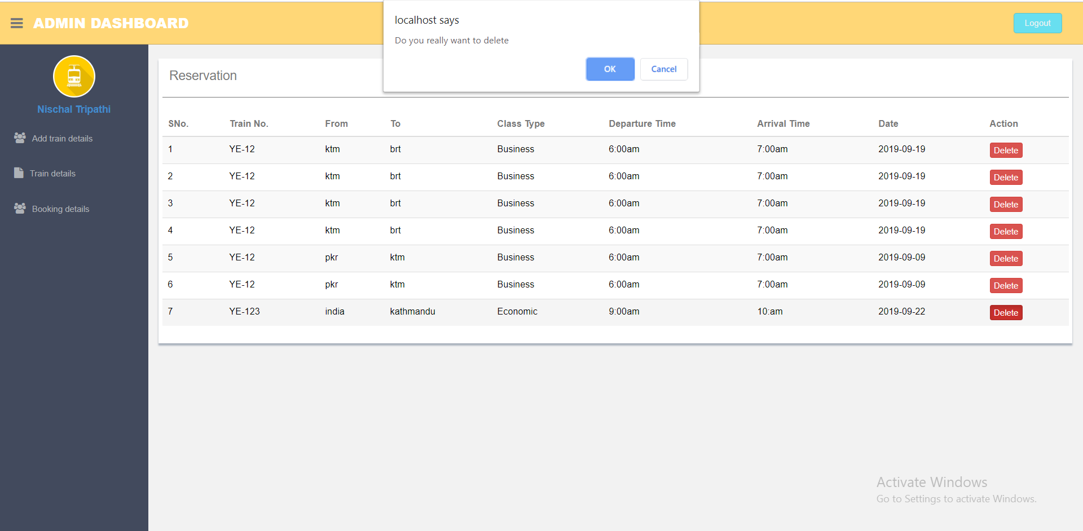

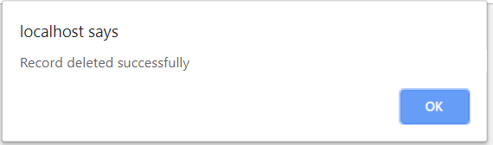

Black box testing 10: Add feedback

|  |  |  |  |  |  |
| --- | --- | --- | --- | --- | --- |
| Test Case | Description | Task | Expected Result | Actual Result | Conclusion |
| 1 | Add feedback | Fill the given details. | Feedback must be added successfully. | Feedback added successfully. | Pass |
| 2 | Form validation | Leave any attribute blank. | Error message must be displayed to the user. | Error message displayed. | Fail |

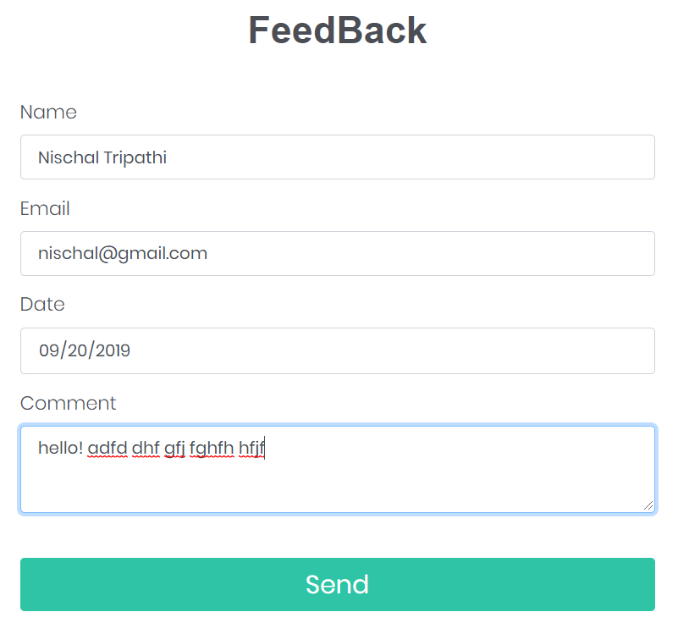

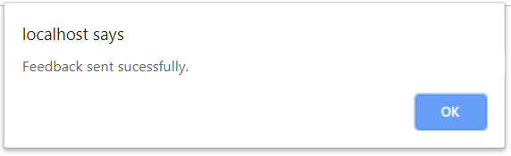

Black box testing 12: Delete feedback details

|  |  |  |  |  |  |
| --- | --- | --- | --- | --- | --- |
| Test Case | Description | Task | Expected Result | Actual Result | Conclusion |
| 1 | Delete feedback details. | Admin can select the data from table and delete it. | Feedback must be delete. | Record deleted successfully. | Pass |

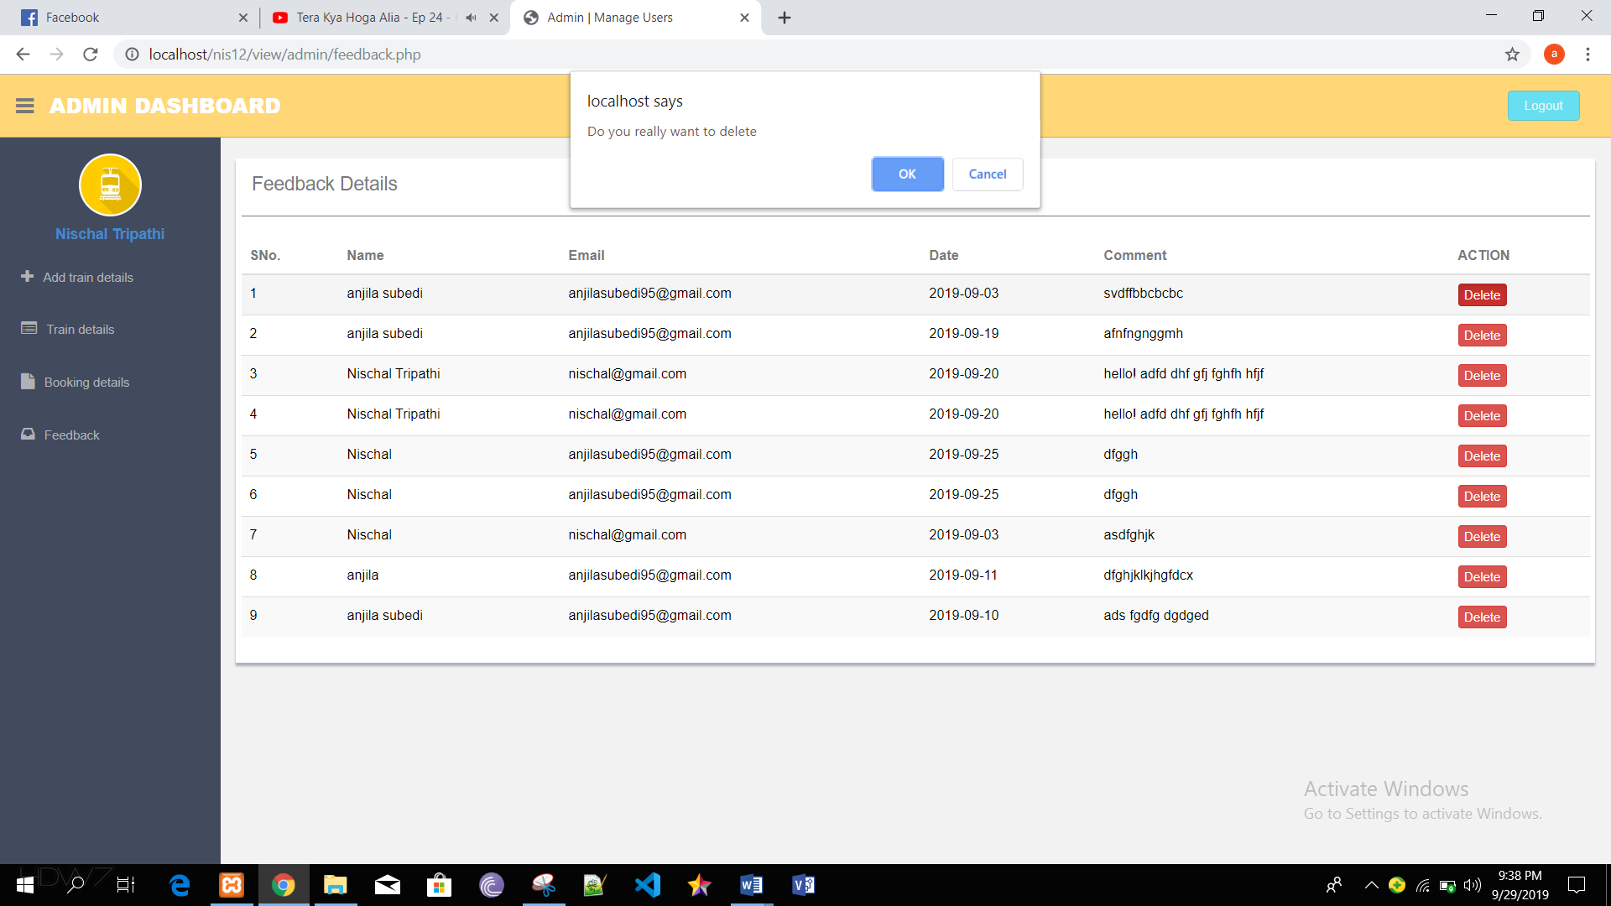

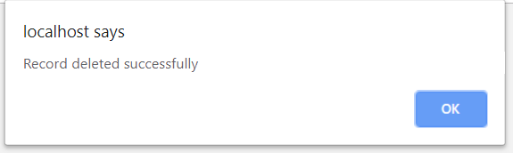

Black box testing 12: Cancel ticket

|  |  |  |  |  |  |
| --- | --- | --- | --- | --- | --- |
| Test Case | Description | Task | Expected Result | Actual Result | Conclusion |
| 1 | Cancel the booked ticket. | User can cancel the tickets. | Ticket must be canceled successfully. | Ticket cancelled successfully. | Pass |

Output:

